How to transcribe
This training manual covers:
- Software for transcription
- The qualities of a good (or good-for) transcript
- Transcript metadata
- Treatment of audio and video records for transcription
- Resources & tips

A Primer from the Learning Sciences

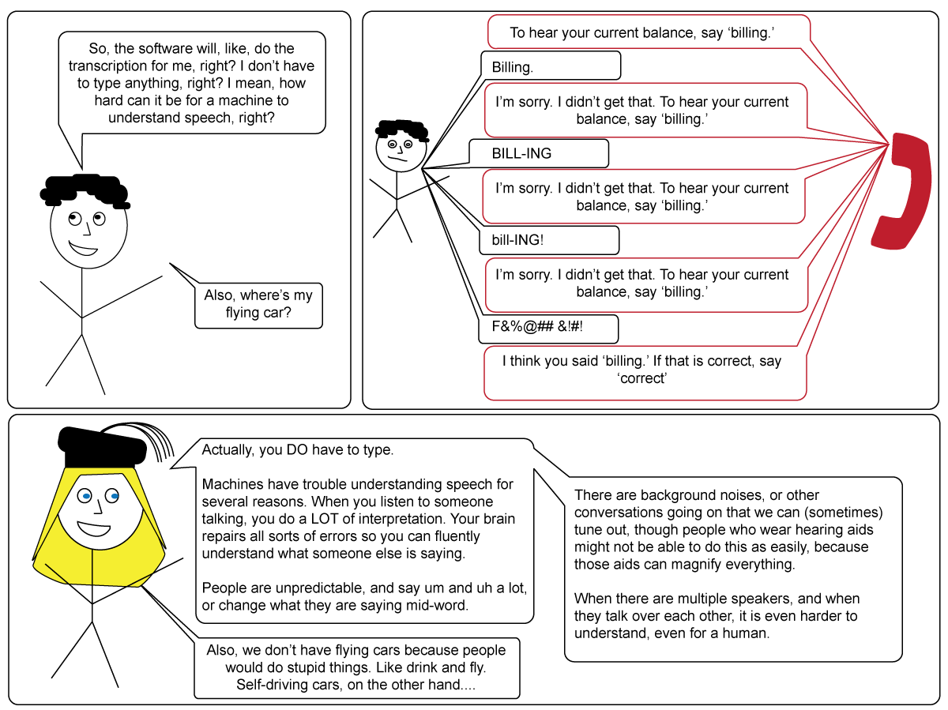
Software for transcription
Some of the best software we have found for a first-pass auto-transcription relies on GoogleVoice, and is called Descript. Please sign up for an account here to earn 100 minutes (instead of 30):
- https://app.descript.com/r/Bk2wKhwEz
As a caveat, because this is trained on GoogleVoice, it tends to over-guess the frequency of swear words and common and trending words. It does not catch technical terms well.
There is also software to make the typing easier. We’ll focus on InqScribe, but you might be able to find other programs that can do the same thing.
- Download it: https://www.inqscribe.com/download.html
The website has lots of helpful info http://docs.inqscribe.com/2.2/. If you cannot save (because you are using a free/limited version) just copy and paste into/from a word document. Student licenses are pretty affordable.

What can good transcription software do?
Software like InqScribe makes the transcriptionist’s job a bit easier:
- Toggle play/pause with tab or a foot pedal
- Insert time stamps with a key stroke:
  - Mac: command ;
  - PC: control ;
- Slow down playback
- Set a skip-back when you pause. Many people find having the record jump back 3 to 8 seconds to be helpful, because by the time you are pausing, you have usually already missed something
- Make a supra- or sub-titled video
- Export transcripts to a spreadsheet, like Excel, or to Word for data analysis
- There is no spell check; this can be good, because those little red underlines slow your typing down when you notice them

Software for transcription

The Qualities of a good (or good-for) transcript
Different researchers do different things with transcripts. Sometimes a content log—a time stamped list of what the record contains—is all that is needed.
A transcript, on the other hand, is a lot like a script. It should identify the speaker (usually by a pseudonym) and what the speaker said. Sometimes, it needs to include supplemental information to help convey meaning, especially if a speaker is using sarcasm. It may also need to describe actions or gestures, particularly for videos. The level of detail in the transcript needs to make it good for the type of analysis that will be done.
Usually, we want all the words—including ums and uhs—because they can tell us a lot about how confident a speaker is. They give us important clues.
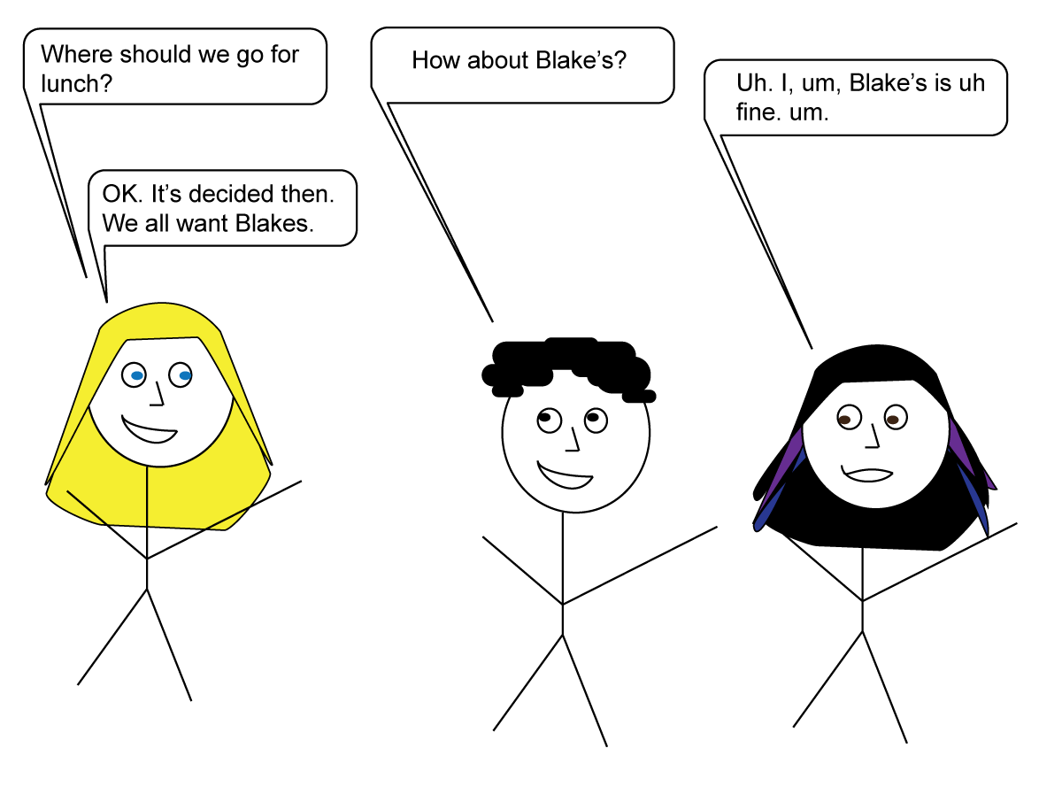
I don’t think she wants to go to Blake’s.

Basic transcription
A basic transcript should include speaker, turns of talk, and time stamps. Other things to note:
- Call out nonverbal information in double parentheses ((she laughs))
- We typically use double parentheses for notes because software tends to read square brackets as a timestamp, and in Word, software like EndNote tries to read curly brackets as a citation to be inserted.
- Double parentheses can also be used to call out inferences ((I think she is being sarcastic here)). Always start with “I think” or “I wonder” to indicate it is your inference. Don’t make this your focus, but it can be helpful to document the things that strike you, that only listening will make clear.
- Sometimes parts are not possible to hear clearly. Note this and include time stamps if it is long ((inaud)).
- Sometimes people talk “off task” or about logistics. It may be okay to not transcribe this, but bracket it with time stamps and include a description of what was said, in case it turns out to be important later. Also note that the term “off task” is offensive to some researchers because often, important social, relationship, trust building stuff happens there.
- Put timestamps in often.
- Hit enter/return often—whenever you hear little breaks or pauses, between sentences, or between clauses. These are easy to join back up later if needed, but most humans can hear “chunks” of talk
- Because InqScribe does not have spell check, make sure you copy-paste into Word, fix the spelling, then paste back into InqScribe (or save the Word version)
- Spell words the way they are spoken. If someone says “I’m fixinta kill them furrants” don’t change it to “I’m fixing to kill those fire ants.” If someone uses the wrong word, don’t correct it for them.

example of a basic transcript
[00:00:34.14]
B: Tell me about a time you wish you’d known more about nutrition, in your work with patients.
P: Hah! Nutrition is such a waste of time. Nobody needs that stuff. Right? ((Laughs))
[00:01:02.17]
((P sees a text message come in on her phone, responds to it, no one else talks for a while, but she tells about the text she got))
[00:01:41.04]
B: How about you Craig? Was there a time you wish you’d known more about nutrition, in your work with patients?
C: Um, well, I think, I mean, uh, it’s important. I remember this one time, I saw this uh girl, this woman, and she said she was uh vegan,
[00:02:03.04]
C: and I think maybe she had a deficiency, or something, but I didn’t really know whether it was important or where to find information for (.) to help her, you know.
[00:02:55.09]
C: I was gonna look it up, but I ran out of time. I kept thinking, I gotta do that cause it’s important.
P: It is so important. That’s why we all took classes in it. ((I think she is being sarcastic here because they said they did not have any classes. Her tone sounds sarcastic to me))
B: Thanks Craig. That’s helpful.

Conveying tone and cadence in transcripts
Sometimes we use a few “Jeffersonian” conventions to better convey the tone and cadence of conversations (see resources for more on these conventions). Often, we only do this with transcript we share in a talk or paper, but sometimes we need to be able to “hear” the transcript to make sense of it. This includes adding our own interpretations and inferences sometimes.
- A WORD in all capital letters indicates that it was spoken in a loud voice. Capital letters used WITHin a word indicate that a syllable was spoken in a loud voice, but the rest of the word was not.
- A wo:::rd with colons indicates the sound was drawn out
- // indicates overlapping talk
- (.) indicates a noticeable pause, a longer pause is noted with how many seconds it lasted (.7s) for 7 microseconds, which is easy to figure using slowed down audio on InqScribe
- Runwordstogether when they are spoken very quickly as if they were one word
- Punctuation is used to indicate tone; thus a question mark is only used when the tone conveyed a question, regardless of grammar.

Example of a transcript with tone and cadence
[00:02:35.27]
Mr. W: Who are you designing for? (.) A homeless person, right? So really, what we are looking at her::::e ((white board)) //
[00:02:41.09]
Mr. J: // So, that’s your client guys. (.) So, who is the client, right. You can't sit down and—((I think he changed his wording mid sentence)) You can start designing something, but until you know WHO you are building that for, and what their SPEcific needs are, you're gonna probably be pretty far off the mark as far as what your end product looks like, right?
[00:02:45.11]
If you know these questions, maybe come up with questions to begin with, right, and use that to inform the design you create, what do you guys think? Is that gonna end up being a better design, or is your design gonna be worse?
[00:02:50.18]
Mr. W: So that means that step number ONE in this process is gonna be what we call a needs assessment.

The Qualities of a good (or good-for) transcript

Transcript Metadata
Your transcript must include metadata—data about the data that can help researchers know what is going on and how the transcript relates to other data. Every transcript must include the following information, at the top of the transcript.

Date of transcription:
Name of researcher making transcript:
List of all related files:
Date of original data collection:
Speakers:
Context statement:

Example of transcript metadata
Date of transcription: 2016 03 12 (include only numbers, 4 digits for year, then month, then day, with leading zeros)
Name of researcher making transcript: Vanessa Svihla (your first and last name)
List of all related files: (list one file per line)
FieldNotes20151203.docx
Audiofile20151203.MP3
Date of original data collection: 2015 12 03 (include only numbers, 4 digits for year, then month, then day, with leading zeros)
Speakers: (one per line; the name and how they are noted in text)
Beth = B
Paloma (a pseudonym) = P
Craig (a pseudonym) = C
Context statement: (Briefly describe what is going on in the transcript. Make note of anything especially interesting) This is an interview between researcher Beth, a medical student (pseudonym Paloma), and a resident (pseudonym Craig). They talk about past experiences. Paloma reveals she thinks nutrition is a huge waste of time.

Transcript Metadata

Treatment of audio and video data
If the data you are transcribing includes human voices, faces, or even just hands, the data must be treated very carefully. You might be surprised by some of the things that could get you in trouble, depending on how the protocol was written and approved.
Researchers have to go through a great deal of effort to get approval to collect and work with audio and video records.
In general, you should follow the guidelines below:
- Never store the file online, such as in a google drive, on youtube, or similar.
- Don’t let iTunes get ahold of data. If iTunes opens your data, it makes another copy of it in its library, unless you have specifically changed how iTunes works. In general, this means you need to open with (on a PC, right click. On a Mac, two-finger tap. Choose “open with” then select an audio or video player other than iTunes).
- If you make a mistake and iTunes gets your data, find that extra copy in the iTunes library and delete it RIGHT NOW
- Don’t email the data
- Only store the data on devices that are password protected
- Make sure the data are backed up somewhere, but delete the data from your personal device once you have completed the transcript, and empty your trash can to make sure it is really deleted

Treatment of audio and video data

Resources and Tips
Transcribing takes time. Give yourself about 5 minutes for every minute of data you need to transcribe, and more if there are many speakers in a noisy room. Give yourself about 10 minutes for every minute if you are noting cadence and tone.
Sometimes it can help if you transcribe when you are relaxed or tired. This seems to lower your inner critic. Some people suggest having a glass of wine when transcribing! Just make sure you do a sober, wide-awake accuracy check when finished.
Wear comfortable, noise-cancelling earphones for the best transcription experience.
Great papers for learning more about the ways different people transcribe:
- Jefferson, G. (2004). Glossary of transcript symbols with an introduction. Conversation analysis: Studies from the first generation, 13-31.
- Ochs, E. (1979). Transcription as theory. In E. Ochs & B. Schieffelin (Eds.), Developmental pragmatics (pp. 43-72). New York: Academic Press.
- Schegloff, E. (2000). Overlapping talk and the organization of turn-taking for conversation. Language in Society, 29(1), 1-63.
- Atkinson, J., & Heritage, J. (1999). Transcript notation-structures of social action: Studies in conversation analysis. Aphasiology, 13(4), 243-249.
- Dressler, R., & Kreuz, R. (2000). Transcribing oral discourse: A survey and a model system. Discourse Processes, 29(1), 25-36.
- Edwards, J., & Lampert, M. (1993). Transcription and coding in discourse research: Hilldale: Lawrence Erlbaum.
- Edwards, J., & Lampert, M. (1993). Talking data: Transcription and coding in discourse research. In J. Du Bois, S. Schuetze-Coburn, S. Cumming, & D. Paolino (Eds.). Hillsdale, NJ: Erlbaum.
- Lapadat, J., & Lindsay, A. (1999). Transcription in research and practice: From standardization of technique to interpretive positionings. Qualitative Inquiry, 5(1), 64.
- Roberts, C. (1997). Transcribing talk: Issues of representation. TESOL Quarterly, 167-172.
- Goodwin, C., & Heritage, J. (1990). Conversation analysis. Annual Review of Anthropology, 19(1), 283-307.
- Schegloff, E. (2004). Putting the interaction back into dialogue. Behavioral and Brain Sciences, 27(02), 207-208.
Curious about what happens next? Here are some of the things that might happen to a transcript:
- Jordan, B., & Henderson, A. (1995). Interaction analysis: Foundations and practice. Journal of the Learning Sciences, 4(1), 39-103.
- Cobb, P., & Whitenack, J. (1996). A method for conducting longitudinal analyses of classroom videorecordings and transcripts. Educational Studies in Mathematics, 30(3), 213-228.
- Chi, M. T. H. (1997). Quantifying qualitative analyses of verbal data: A practical guide. The Journal of the Learning Sciences, 6(3), 271-315.
- Schegloff, E. (1993). Reflections on quantification in the study of conversation. Research on Language and Social Interaction, 26(1), 99-128.

Happy transcribing!

